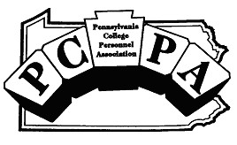

Sharing the
Commonwealth

Volume 29, Issue 2 March 2004

President’s Message: Ken Miller, Penn State Erie, The Behrend College

F. Scott Fitzgerald once said "The test of a first-rate intelligence is the ability to hold two opposing ideas at the same time being, and still retain the ability to function." I find my own intelligence tested with the idea of Spring Break upon us and the challenge of balancing time away with the need to get caught up (or let’s just say less far behind). Thankfully (?), Mother Nature has seen fit to coat this Spring Break in Erie with snow which makes it a tad easier to focus on the tasks at hand!

There are, however, several wonderful opportunities to relax and rejuvenate with colleagues in the coming weeks. The Spring Keystone Seminars are upon us at east and west locations. The focus is on experiential learning and features great information on best practices in service learning, adventure education, and learning communities. Brian Mauro (Penn State, Lehigh Valley) is coordinating registration for the March 19th Keystone at the Penn State, Lehigh Valley campus. Erin Heasley (University of Pittsburgh, Johnstown) is coordinating the west Keystone at Pitt Johnstown. More information is available at our website www.pcpa.net.

Also coming up fast is the ACPA national conference in Philadelphia, PA. I would like to invite you to drop by the PCPA reception on Sunday, April 4 from 8:30 to 10:30 p.m. We will be in Marriott 304 and I hope you’ll take some time to stop in. Thanks to Brian Mauro (Penn State, Lehigh Valley) for his coordination with ACPA.

Finally, this will be my last message as President of PCPA and I would like to thank the Executive Board for their service to the organization and the membership for their participation. In particular, I’d like to thank Dwayne Hilton (Penn State Hazleton) for his support and guidance, Charmaine Strong (Seton Hill University) for keeping me on deadline, and Mary Ellen Bayuk (Penn State Behrend) for stepping up to the membership chair challenge! What a great group of people. Thanks for the opportunity to be a part of such vibrant organization.

See you in Philly!

Ken Miller, Ed.D.
Director of Student Affairs
Penn State Behrend

Serving Students Affairs and Higher Education Professionals Across Pennsylvania
Page 2 SHARING THE COMMONWEALTH
THEME: experiential education
_____________________________________________________________________________________
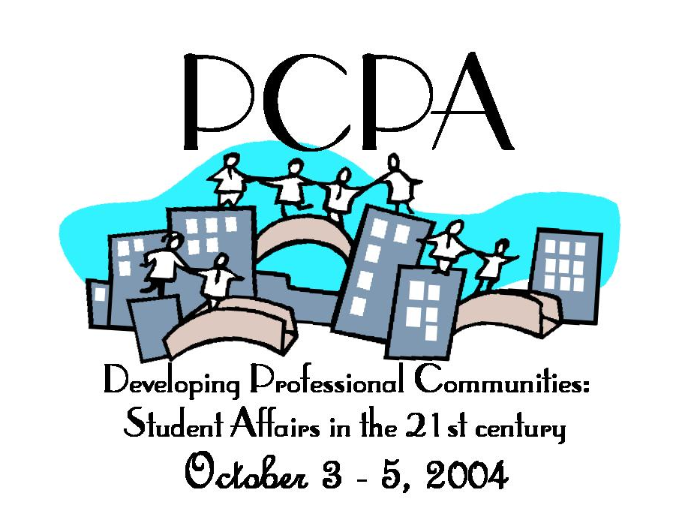_____________________________________________________________________________________

“Developing Professional Communities:
Student Affairs in the 21st Century”
PCPA Conference 2004

The theme and site for the 2004 annual conference has been determined. “Developing Professional Communities” will be held at the Holiday Inn—Harrisburg West, Sunday, October 3 through Tuesday, October 5, 2004. Stay tuned for the call for programs and registration information. Jan Schumacher, Muhlenberg College and Todd Jones, Community College of Philadelphia are conference co-chairs. Conference committee members are Kelly Finley, Erin Heasley, Robin Illsley, Jess Manno, Scott Mattingly, Sue Norton, Kaycee Palko, Kristen Radovanic Corcoran, Amber Sherman and Jaimie Steel.

If you have suggestions or questions, please e-mail Jan, schumach@muhlenberg.edu, or Todd, tjones@ccp.edu.
_____________________________________________________________________________________
Page 3 SHARING THE COMMONWEALTH
THEME: experiential education
____________________________________________________________________________________

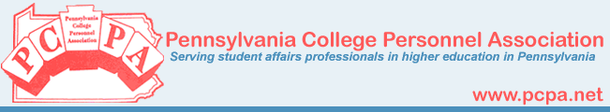

FROM THE MEMBERSHIP CORNER

PCPA Current Membership Data Base: 202
A breakdown of the membership follows:

Institution Type  - Unknown 2  - Two Year CC 25  - Four Year Public 106  - Four Year Private 69   | Membership-At-Large (MAL)  Representation  - Two Year East—11  - Two Year West—14  - Four Year East Private—34  - Four Year West Private—39  - Four Year East Public—22  - Four Year West Public—82
_____________________________________________________________________________________

BOARD BRIEFS

- Total Assets as of January 23, 2004 are $20, 847.51 ($12, 425.15 in checking and $8, 422.36 in savings).

- Since October 19th, PCPA has welcomed 24 new or renewed members. There are 202 members and 159 are signed up for the list serve.

- Concern has been expressed about participation with Grady Roberts Award and the Journal. The board is considering ways to encourage members to submit.

- The next Keystones are March 19th and March 26^{th.} The east will be held at Penn State Lehigh Valley on the 19th with the west at The University of Pittsburgh Johnstown on the 26th.
_____________________________________________________________________________________
Page 4 SHARING THE COMMONWEALTH
THEME: experiential education
_____________________________________________________________________________________

CLICK ON THIS…….

Claudia Mokwa
Resident Director, Gannon University

Association for Experiential Education:
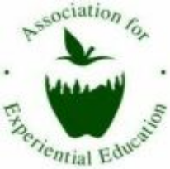
This link takes you directly to the organization's FAQ page. It provides plenty of links and contact information to get you started in planning your own experiential learning programs, especially physical events. Information on obtaining grants and insurance is covered. Also, they created a list of definitions and purpose statements for these programs. Great starting point!!
http://www.aee.org/faq/nfaq.htm

Center for Experiential Education and Academic Advising within the Colleges of Arts and Sciences at Northeastern University:
This link is a PDF file that contains information on experiential education in how it relates to academia. Several projects for majors are provided as a way to extend classroom learning.
http://www.casdn.neu.edu/cea/resources.html#


University of Washington (Seattle, WA):
This link is a Microsoft Word document that provides a chart comparing several types of Experiential Education: service learning, internships, volunteerism, and community service in terms of their definition, purpose, benefits, duration, and planning involved. Great "cheat sheet" that can be used to assist with the initial planning stages.
http://depts.washington.edu/leader/3_service/Experiential%20Education%20Matrix.doc

_____________________________________________________________________________________
Page 5 SHARING THE COMMONWEALTH
THEME: experiential education
_____________________________________________________________________________________

The Education of Service: Students’ Perspectives

Cynthia Boland
Director of Campus Ministry
Seton Hill University

Over the years I have had the opportunity of accompanying college students on several service trips. When I asked a variety of students who attended a recent Spring Break Trip to Appalachia about what they learn from participating in service projects and trips, many of them remarked that so much of what they learn can’t be taught in a classroom, at least not to the extent they can learn it through experience. Three particular areas that stood out from our conversation were: Clarity in assessment, Community, Self-awareness. Let me elaborate.

Clarity in Assessment: One student commented that the experience of meeting people who face the struggle of poverty everyday, working side-by-side with them, hearing their stories, observing the resources they have available to them (or not), discovering their creative use of these resources, and collaborating with them in meeting their needs, enabled the student to better evaluate the conditions of the poor. He gained a clearer understanding of the obstacles that face those experiencing poverty, not from a textbook, but from the lived experience of the people. This experience provided a bigger picture for this student to work from in understanding the causes of poverty and the impact of poverty on the lives of people. It also provided some understanding and direction as to what needs to take place on a societal level in addressing the problem of poverty. Through this experience, poverty and social change did not remain for him a theory, statistics, or a case study – it was real.

Community: One of our main goals as colleges and universities is to prepare our students to be full, active, capable participants in the larger world community. We do our best to create the experience of community in our school atmosphere, our clubs and teams, and in residence life. Service projects and trips are a vital part of this experience of community. Service projects/trips are opportunities for students to meet on a common ground with people from different life experiences, socio-economic and educational backgrounds, perspectives and cultures to collectively contribute to the welfare of all, believing the welfare of all is important. By stepping into situations that are different from their own, the students expressed they learned that we are not so different despite our diversity in experiences, thought, and expression. They came to understand that when we gather together and pool our viewpoints, experiences, skills, resources, etc. that a sense of appreciation for each other and what was created together helped them feel a greater sense of connection with the other students and those they came to serve. This was certainly the sentiment of one student interviewed who said, “the sense of community you gain from sharing meals together, sharing the bathroom, building a house together you just can’t learn from a book. You just have to do it to know it.”

Self-awareness: For many, and it was certainly true for the students on this recent trip, working together with others on causes that benefit the larger community, especially the disadvantaged, often causes them to reflect further on their own inner self. On a positive note, students become aware of skills, talents, and developing hopes and ambitions they may not have noticed before. But what I observe as the greater sources of personal growth the students experience on such trips comes when they realize the advantages they’ve had; or when they are confronted by
Continued on page 6

Page 6 SHARING THE COMMONWEALTH
THEME: experiential education
_____________________________________________________________________________________
Timely Thoughts on Experiential Education - Continued from page 5

prejudices they didn’t realize they held; or when
they became attentive to changes they need to make in their lives. Through service projects and trips, students often gain a clearer understanding of where they came from, who they are now, and who and how they want to become. Many students say that such experiences really help them to put their priorities in order and consider what is truly valuable in life, with the hope of making it a way of life.

____________________________________________________________________________________
SPRING 2004 KEYSTONE SEMINARS
Theme: Experiential Education

LEARNING COMMUNITIES SERVICE LEARNING ADVENTURE EDUCATION

Experiential Learning serves as a marriage between the walls of a classroom and the rest of the world, resulting in the development of new skills, understanding, and knowledge. Despite the diversity of experiences, they all commonly provide students with direct contact to the society, community and social environment that they will soon inhabit. This Keystone will focus on several types of non-credit experiential learning styles, including Adventure Based Education, Service Learning, and Learning Communities.



Keystone East Information Keystone West Information
Date: Friday, March 19, 2004 Date: Friday, March 26, 2004
Time: Registration 9:00-10:00 AM Time: Registration: 9:00 AM – 10:00 AM
Keystone from 10:00 AM-3:00 PM Keystone from 10:00-3:00 PM
Location: Penn State, Lehigh Valley Location: University of Pittsburgh-Johnstown
Registration: Brian Mauro Registration: Erin Heasley
Assistant Director of Student Affairs Area Coordinator
Penn State Berks - Lehigh Valley University of Pittsburgh-Johnstown

Contact: Jaimie Steel
Steel@setonhill.edu
724-830-1076
_____________________________________________________________________________________
Page 7 SHARING THE COMMONWEALTH
THEME: experiential education
_____________________________________________________________________________________

Timely Thoughts on Experiential Education

Brenda Fabian, Assistant Director
Center for Career Services
Susquehanna University

Many of us already encourage our students to seek out experiential learning opportunities in the form of internships, externships, co-op programs, practicum experiences, job shadowing, field work and volunteer service learning, just to name a few. Of course there is experiential education in the form of active involvement in clubs, organizations, athletics, Greek life and leadership activities. With all of these opportunities available to students, it is easy for them to understand the benefits and the uniqueness of this type of learning. Right? On the contrary, communicating the benefits and advantages to students is often the greatest challenge.

Experiential education helps introduce and socialize students into the environment and culture of their potential career field. These opportunities allow students to gain direct experience which is essential, because even in an excellent job market, students with experience still have a competitive advantage. If an internship is done to explore and confirm a career choice, it shows initiative, determination and dedication. Employers often feel more comfortable hiring a person with some experience or exposure to the job since the individual is less likely to report that the job isn’t what he expected. If the internship is done only to eliminate a career choice or determine that the job just isn’t a match, it gets the student one step closer to his or her ideal position.

Students who take advantage of experiential learning opportunities have less difficulty transitioning into the work force as employees. They become familiar with reporting structure, professional dress code and inter-office etiquette. When transitioning into the work place for the first time, knowing some of the often unspoken rules can make the adjustment a little less overwhelming. Students also learn essential skills and expertise necessary for their career, provided they have made a good site selection. Whether the experience is paid or unpaid, compensation will come in the form of knowledge, experience, confidence, credibility and access to a professional network.

Many of us can also agree that classroom and experiential learning are both valuable experiences. However, we may find ourselves in situations where we need to remind students that the purpose of each is very different since the academic and experiential lines can become blurry. You may have heard students remark, after successfully completing an enlightening internship, that they learned so much from their internship, but much of it was unrelated to what they’ve learned in the classroom. It is important to remind students that their education will compliment their work experiences but it is not meant to teach them how to perform a particular job. That is precisely what on-the-job training is intended to do. It is not always possible or even realistic to expect that job experience can or should somehow be replicated in classrooms.

Continued on page 8

Page 8 SHARING THE COMMONWEALTH
THEME: experiential education
_____________________________________________________________________________________
Timely Thoughts on Experiential Education - Continued from page 7

A proven and successful combination is the merging of both academic learning and work experience to truly enrich student’s learning. What is unique about intentional experiential education is that it is a planned, controlled experience that usually incorporates additional reflection. Academic courses are structured at the beginning of each semester. So to is experiential learning, but in addition, it allows and challenges the student to create his or her own individual blueprint as it relates to a distinct job. Experiential learning is much more than simply working somewhere and completing a set number of hours. Work experience does not merit academic credit or we would still be adding to our transcripts.

The academic component for which credit is assigned is given for the planned learning activity that is based on the student’s goals and objectives. This distinct difference is what employers find invaluable and why they are normally more interested in the students who complete professionally-based experiences as opposed to informal, less structured experiences. The benefits are obvious to most educators but not always so obvious to students. With summer closing in, it is time to remind students to take advantage of these opportunities before it is too late.

_____________________________________________________________________________________

HIRING? LOOKING FOR QUALIFIED STAFF?

For decades the Indiana University of Pennsylvania (IUP) SAHE program (Student Affairs in higher Education) has produced and distributed Mini-Resumes to introduce the graduates of the MA program to the professional community. Those condensed resumes are now available for viewing through the program’s website. If you have professional searches to conduct and would like to view the credentials of the upcoming graduates from IUP, please click on the Mini-Resume link at this address: http://www.iup.edu/sahe/



_____________________________________________________________________________________
Page 9 SHARING THE COMMONWEALTH
THEME: experiential education
_____________________________________________________________________________________

Grady and Mary Roberts
Graduate Student Writing Award


The Pennsylvania College Personnel Association is pleased to announce the Grady and Mary Roberts Graduate Student Writing Award. Submissions are now being accepted for the 2004 award.

Encouragement and recognition of scholarly writing by graduate students in current issues in Student Affairs is the purpose of the award. Students in masters or doctoral programs are invited to participate.

The award is donated by Dr. Grady H. Roberts Jr., past president of PCPA, in memory of his parents. The winner will be announced at the 2004 Annual PCPA Conference in October. The amount of the award is $500.00.

Eligibility

Students must be:
- Enrolled in a graduate degree program for one or more semesters during the 2003-2004 school year. Verification is required.
- A current member of PCPA. (Student membership is $10.)
- Planning to attend the annual PCPA fall conference.

Procedures

- The topic of the award is a major issue in Student Affairs.
- Submittals must not exceed ten (10) double-spaced typewritten pages including references, tables, and figures, and should conform to the American Psychological Association Publication Manual (4th edition).
- Submit (2) copies of the manuscript.
- Entries will be judged on originality, clarity, significance of the topic to the field of Student Affairs, technical competence, and forcefulness of argument.

All entries must be postmarked no later than June 1, 2004 to:

Dr. Grady H. Roberts, Jr.
5323 Broad Street
Pittsburgh Pa. 15224
_____________________________________________________________________________________
Page 10 SHARING THE COMMONWEALTH
THEME: experiential education
_____________________________________________________________________________________Employers and Internships

Compiled by: Rebecca Campbell
Director of Career Services
Seton Hill University

Whether you are a student selling yourself to an employer or an organization looking for an intern, knowing the benefits, the responsibilities, and the steps to a successful internship is beneficial.

Employer Benefits

Internships:
- Motivate students to perform. They are found to have significantly better than average productivity rates.
- Offer savings on fringe benefits and wages.
- Enable employers to fill temporary staff vacancies, such as those created by vacation or maternity/paternity leave.
- Enhance work environment with new ideas and insights.
- Empower an employer to experiment with new positions without making long-range employment commitments.
- Generate release time for professional staff to pursue more demanding work.
- Give employers the opportunity to impact directly on and strengthen ties with the academic community.
- Provide employers with the opportunity to prescreen potential employees without making any commitments.
- Create a cost effective way of recruiting entry-level employees.
- Reduce training and orientation costs.
- Invigorate the work environment with new ideas and insights from students.
- Enhance company relations with colleges and college students.
- Give the employer the satisfaction of mentoring young people.

Employer Responsibilities

- Identify the needs of the company/organization
- Write a job description and learning outcomes based on the organization or department needs
- Designate a staff member to establish a close working relationship with the student, internship office and the faculty coordinator
- Complete the internship agreement form and return by the due date
- Determine applicable wages, stipends, or salaries proportionate to the position.
- Establish a work schedule with the student that will accommodate requirements of both the school and the organization
- Assist student in developing and achieving personal, academic, and organizational objectives
- Train and supervise intern, assign duties that are career related, progressive and challenging
- Provide constructive feedback to ensure a worthwhile learning experience
- Provide a safe working environment for students.
- Notify the faculty advisor or internship office of problems that may arise.
- Meet with faculty advisor or internship office during on-site visits to discuss student’s progress
- Complete final evaluation on the student
_____________________________________________________________________________________
Page 11 SHARING THE COMMONWEALTH
THEME: experiential education
_____________________________________________________________________________________

STAYING ACTIVE WITH POAC!
(More Than a Crazy Acronym)

The Past Officers Advisory Committee (POAC) was designed to allow and encourage past board members to stay actively involved in the Association. Over the years the people in POAC have provided support, involvement, and strength to PCPA’s programs and services, and this continues today.

During our fall conference, POAC was responsible for sponsoring the 3rd Annual Chief Student Affairs Officers Breakfast and Roundtable Discussion. Twelve senior level Student Affairs Officers came together for an open exchange and dialogue on campus and student life issues that impact our colleges and our work. The major topics that were discussed at the fall meeting included: substance abuse and those students arriving on our campuses with these problems; providing services and managing the mental health cases on campus; student programming and college partnerships; current legal issues impacting higher education; and community outreach. This Roundtable also ignited informal conversation throughout the conference among colleagues.

Other POAC activities have included: conference presentations by past officers at this annual conference, working with PCPA’s Keystone Seminars, recruitment for PCPA membership, and the coordination of a directory listing senior level Student Affairs Officers at our state colleges and universities, which is now available on our website.

NOTICE – The PCPA Executive Board is interested in recruiting past executive board members for POAC and encourages them to stay active in the association in any one of several ways. The E-Board sees POAC members as important consultants on PCPA affairs, professional development activities and as ambassadors for the association and we want to encourage such involvement in the association.

Joseph Merkle
POAC Co-Chair
Dean of Student Affairs, York College of Pennsylvania
717-815-1460 jmerkle@ycp.edu
_____________________________________________________________________________________

attending the ACPA Conference in Philadelphia???

Please stop by the PCPA Reception…

Sunday, April 4, 2004
8:30pm – 10:30pm

Program ID: 792
Building/Room: Marriott 304

_____________________________________________________________________________________
Page 12 SHARING THE COMMONWEALTH
THEME: experiential education
_____________________________________________________________________________________
2004-2005 PCPA ELECTIONS

VOTE NOW ONLINE!!!
http://www.pcpa.net

Point and Click to Review Candidate Bios
and Register Your Vote.

It is your responsibility as a PCPA member to vote for
Executive Board positions.

The Last Day to Vote is: FRIDAY, MARCH 26, 2004
_____________________________________________________________________________________

The Pennsylvania College Personnel Association does not discriminate on the basis of race, color, national origin, gender, age, affectional/sexual orientation, or disability in any of its policies, procedures or practices. The non-discrimination policy covers membership and access to association programs and activities including but not limited to conferences, placement services, publications, and educational services.

____________________________________________________________________________________

SHARING THE COMMONWEALTH
- Published by the Pennsylvania College Personnel Association; a division of ACPA.
- The newsletter is issued three times a year: March, July, and November.
- Deadline for copy is the 15th of the prior month.

_____________________________________________________________________________________
Address all newsletter inquires to:

Amber N. Sherman
Area Coordinator
Seton Hill University
1 Seton Hill Drive Box 364 F
Greensburg, PA 15601

Voice:
724-830-1089

Email: sherman@setonhill.edu

